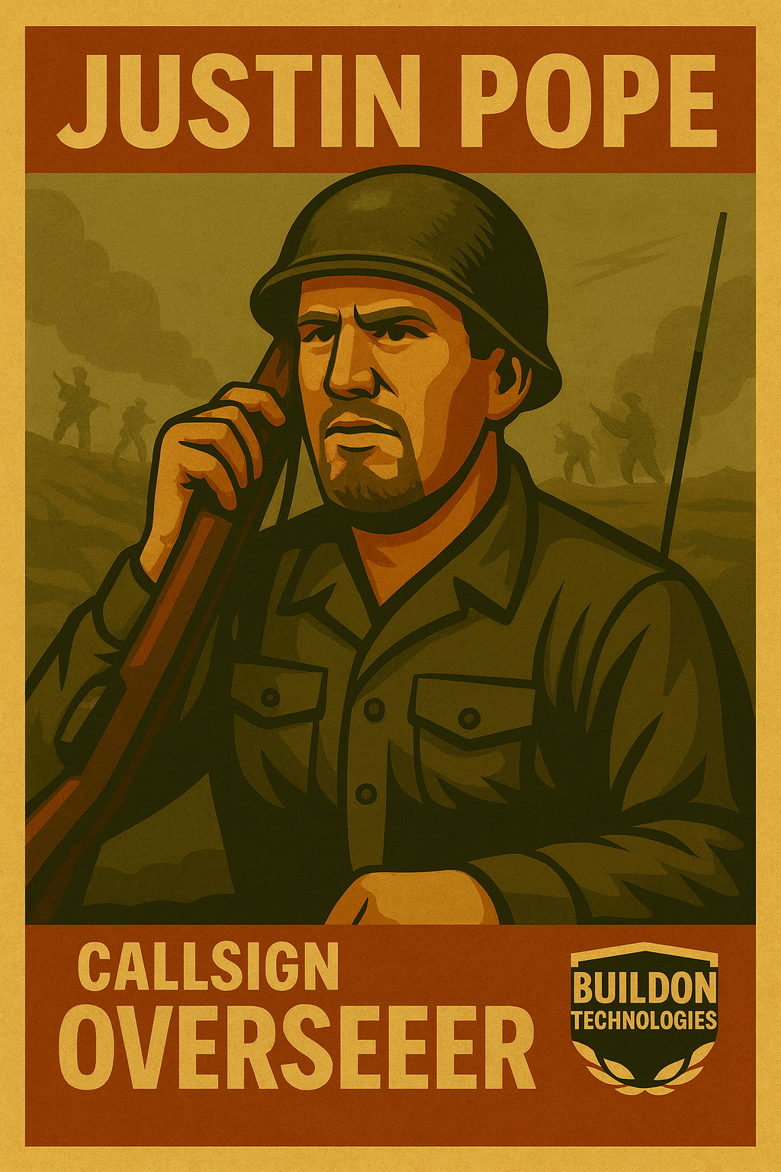

Overseer

Justin  
Pope